Lab 1: Requirements Engineering and UML Use-Case Modelling
Problem Statement #12: Blood Bank Inventory and Emergency Donor Matcher
Target Actors: Emergency Requester, Blood Bank Manager, Donor, SMS Gateway
1. Requirements Specification Table
Req ID | Type | Description | Priority | Acceptance Criteria | Rationale
FR-001 | Functional | The system shall cross-reference emergency blood unit requests against real-time blood bank inventory and broadcast SMS alerts to compatible donors within a 10 km radius. | High | Pass: Compatible donors notified within 30 seconds.  Fail: Incompatible blood group alerted. | Core emergency donor matching functionality.
FR-002 | Functional | The system shall continuously monitor blood component shelf lives and flag units expiring within 48 hours for immediate triage. | High | Pass: Units expiring in 48 hours or less flagged as expiring soon.  Fail: Expired units remain active. | Prevents transfusion of expired blood and reduces wastage.
FR-003 | Functional | The system shall allow the Blood Bank Manager to log new blood units, verify donor cooling-off intervals, and update stock counts. | High | Pass: Logs unit ID or barcode and updates next eligible date.  Fail: Duplicate barcode or ineligible donor accepted. | Maintains inventory ledger and donor compliance records.
FR-004 | Functional | The system shall provide an emergency request intake form for hospital requesters to enter blood group, component type, and unit count. | High | Pass: Form creates a request ID within 2 seconds.  Fail: Incomplete mandatory fields bypass validation. | Standardizes intake data during emergencies.
FR-005 | Functional | The system shall allow notified donors to reply via SMS or link to confirm or decline availability. | Medium | Pass: Donor reply updates confirmed count within 5s.  Fail: Response fails to record on dashboard. | Provides visibility into incoming donors to avoid over-solicitation.
NFR-001 | Non-Functional | The inventory ledger must maintain strict transactional consistency, preventing simultaneous allocation of the same blood bag. | High | Pass: Concurrency test confirms zero double allocations.  Fail: Same unit assigned to multiple requests. | Prevents physical double-booking of scarce blood units.
NFR-002 | Non-Functional | The system shall encrypt all donor contact details and location data at rest (AES-256) and in transit (TLS 1.3). | High | Pass: Audit confirms all donor PII and GPS fields are encrypted.  Fail: Plaintext donor data in network or logs. | Protects donor privacy and meets healthcare standards.

2. UML Use-Case Diagram
Shows actors, use cases, include relationship (Check and Allocate Inventory), and extend relationship (Broadcast Emergency Alert).
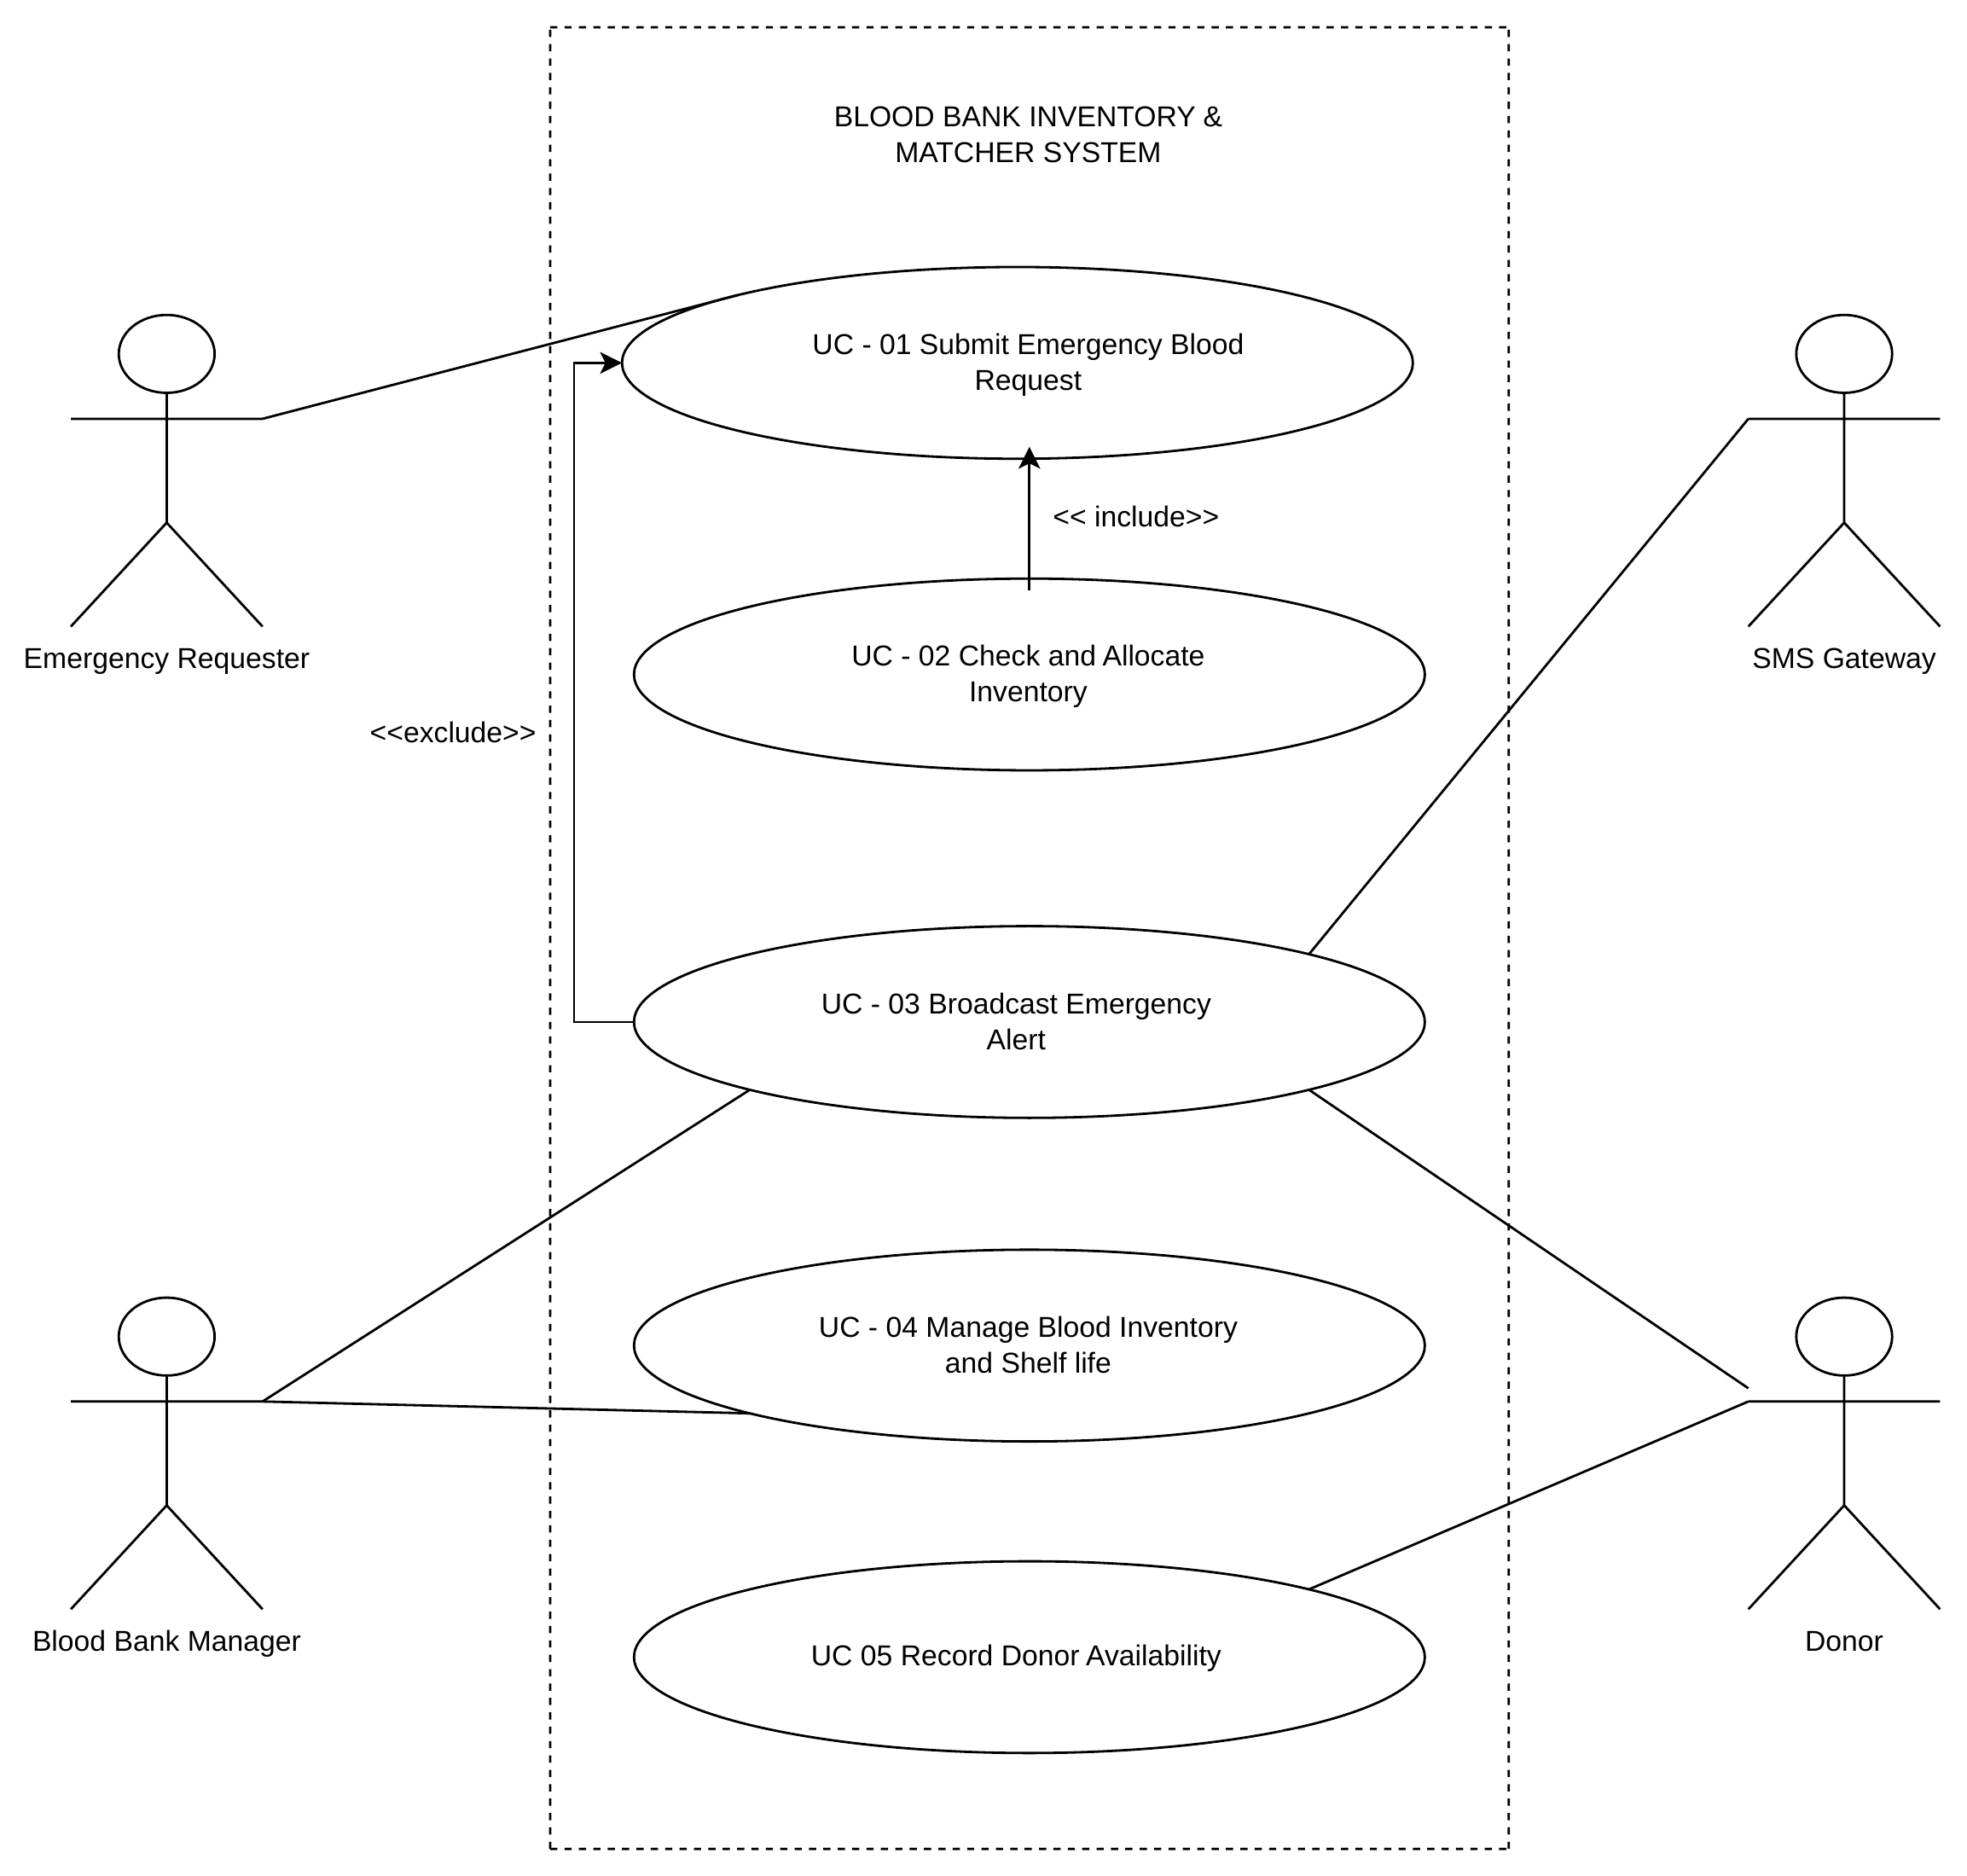

3. Use-Case Flow Specification (UC-01)
Use Case: | UC-01 Process Emergency Blood Request
Primary Actor: | Emergency Requester
Secondary Actors: | Blood Bank Manager, Registered Donors, SMS Gateway
Preconditions: | 1. Requester is logged in.  2. Real-time inventory and donor registry are active.
Postconditions: | 1. Units allocated or dispatched, or emergency alerts broadcast to donors.  2. Request transaction is logged in the database.

Main Success Scenario:
1. Emergency Requester enters blood group, component type, unit count, and urgency level.
2. System validates that all required input fields are filled correctly.
3. System executes UC-02: Check and Allocate Inventory (include) to search active stock.
4. System confirms that matching unexpired blood units are available in inventory.
5. System locks the units to prevent simultaneous allocation to other requests.
6. System generates a dispatch token and decrements available stock levels.
7. System displays confirmation receipt and dispatch details to the Requester.
8. Use case ends successfully.

Alternate Flows:
3a. Inventory Shortage (extend UC-03 Broadcast Emergency Alert):
- 3a1. System detects insufficient matching units in inventory to fulfill the request.
- 3a2. System allocates available matching units and flags the remaining balance as deficit.
- 3a3. System searches for compatible registered donors within a 10 km radius.
- 3a4. System sends SMS alerts with intake location to matched donors within 30 seconds.
- 3a5. System updates the live tracker for the Manager and returns to Main Step 7 with partial fulfillment status.

2a. Input Validation Failure:
- 2a1. System detects missing required fields or invalid input syntax.
- 2a2. System prompts the Requester to correct the input fields.

